Tribal Colleges and Universities

Veterans Health Administration Office of Rural Health

October 2015

Authors:

Carly Shangreau, BS, Program Specialist, Native Domain, Veterans Rural Health Resource Center – Salt Lake City

Carol Kaufman, PhD, Population Scientist, Native Domain, Veterans Rural Health Resource Center – Salt Lake City

Nancy Dailey, MSN, RN, Deputy Director, Veterans Rural Health Resource Center – Salt Lake City

Jay Shore, MD, MPH, Native Domain Lead, Veterans Rural Health Resource Center – Salt Lake City

American Indian and Alaska Natives (AIANs) enter into military service at higher rates than those of other race groups.[1] However, they are also among the least likely to access Veterans’ benefits compared to other race groups. After service, AIAN Veterans may return to their hometowns on or near reservations often located in some of the nation’s poorest rural and highly rural areas.

Studies indicate that the substandard socioeconomic conditions that AIANs face, including income and educational attainment, directly impact health and well-being. AIANs are disproportionately affected by illness, injury, and disease, most of which are preventable, but can be attributed to a poverty-stricken lifestyle.[2] However, a unique opportunity for Tribal Colleges and Universities (TCUs) and the Veterans Health Administration (VHA) is presented as service members return to these communities. Some of these Veterans, especially those from recent conflicts, seek post-separation training and skills development at TCUs.

TCUs are an attractive option for education and training for many AIAN Veterans. Programs are designed to meet local employment needs, and education is provided in cultural context that AIAN Veterans and their dependents often seek. TCUs may provide a unique opportunity for outreach and partnership by the VA to engage and enroll this underserved Veteran population.

However, to date, little is known about TCU programs or outreach activities for Veterans. This report illustrates information about TCUs to assist with planning priorities, building partnerships, and developing strategies for outreach and assisting Veterans to maximize their benefits.

What is a TCU?
Before the TCU movement in the late 1960s early 70s, postsecondary education specifically for AIAN populations was almost non-existent. The need for accessible higher education was of great concern among tribal leaders. They led the movement to address and overcome the barriers to higher education for AIANs through the establishment of TCUs.

In 1968, the first TCU was established in Navajo territory, which is now known as Diné College. Diné College is still operating today, and has expanded to 7 sites throughout Arizona with one of the highest TCU enrollments.[3]

Many of the challenges that these highly rural populations faced in the 20th century still hold true today:
- Geographic isolation of reservations or Alaska Native Villages and transportation needs
- Language and cultural barriers
- Lack of resources and infrastructure (e.g. classroom facilities, housing, daycare options)
- Economic challenges (i.e. many reservation communities are among the poorest in the nation with staggering unemployment rates)

Unlike other public colleges and universities, most TCUs are located on tribal land which make them ineligible to receive funding from the state government. Instead, most TCUs rely on partnerships with various agencies and organizations to include:
- Tribal governments
- Mainstream universities
- U.S. Department of Interior
- U.S. Department of Agriculture
- U.S. Department of Housing and Urban Development
- National Science Foundation
- National Aeronautics and Space Administration

Partnerships with organizations such as those listed above, provide necessary funding and resources, such as; science labs, student research, scholarships, and other incentives. These collaborative efforts are also designed to assist students in the pursuit of advanced degrees at mainstream universities when they have completed a two-year TCU program.

Currently, there are 36 TCUs that serve more than 250 federally recognized tribes that are primarily located in the western and central portions of the United States (see Appendix A).[4] This distribution approximates the geographic representation of the AIAN population across the country. According to the Centers for Disease Control and Prevention (CDC), the states with the highest AIAN population are Alaska, Oklahoma, New Mexico, South Dakota, and Montana.[5]

In 2010, TCUs served 19,070 full and part-time students, most of whom are AIANs living on or near a reservation community. TCUs vary in size, ranging from fewer than 50 students to some having more than 2,000. During the same academic year, TCUs offered 358 apprenticeship, diploma, certificate, and degree programs in 36 major disciplines. All TCUs offer associate’s degree programs, 11 offer bachelor’s degree programs, and only 2 have master’s degree programs. All TCUs are either accredited or a candidate for accreditation by a regional institutional accrediting association that is recognized by the U.S. Department of Education.

What is unique about TCUs?
Tribal identity and preservation is at the core of every TCU, and all share the mission of tribal self-determination and service to their respective communities.[6]

TCUs incorporate culturally relevant curricula and several TCUs require relevant courses in these areas. For example, Oglala Lakota College (OLC), located in western South Dakota has a Lakota Studies Department and all students are required to take courses, such as Lakota Language, Culture, and History.
OLC offers a course titled “Traditional Plants, Foods, and Herbs.” In this course, students learn the importance of making use of what’s available in the surroundings. The instructors take students to areas of the reservation that have an abundance of plants that were used for medicinal purposes. “You learn what type of environment they flourish in, what they look like, when they are ready for harvest, and all the various uses.” (Student at OLC).

AIAN cultures have relied on oral teachings to pass on knowledge from one generation to the next. This is still an important concept among tribes.

Aaniiih Nakoda College located in Montana invites tribal elders to pass on teachings through film and/or audio recordings. They are able to preserve the teachings from these elders and incorporate these into their cultural courses.[6]
It is common among TCUs to have on-site daycare facilities as many of their students are caretakers, and daycare is often scarce or not affordable. To overcome this obstacle, TCUs decided it is in the best interest of their students to provide free or reduced fee on-site daycare.

Other common traits of TCUs:
- All TCUs began as two-year institutions
- Most are less than 25 years old
- Relatively small student body that are predominately AIAN
- Located on remote reservations with no or minimal access to other colleges
- Chartered by their respective tribe but independent of tribal government
- All have open admission policies (the only requirement is to have a high school diploma or GED certificate to be able to enroll at any TCU)
- Several offer GED tutoring and testing
- Most TCUs do not actively recruit or have targeted efforts but instead rely on word of mouth

TCUs often serve multiple roles in their respective communities. Not only do they make higher education possible, but have numerous programs to assist community members as well:

- Several TCUs offer General Equivalency Diploma (GED) preparation and testing.[6]
- Many open their doors to the public and allow for use of computer labs to assist with creating resumes, filling out online applications for various programs, and printing services. Usually this is free to the public, as long as the service is being used appropriately.
- TCUs often partner with local tribal programs and allow use of classrooms for various services, such as finance and budgeting classes, health programs, community gatherings and meetings.
- As part of the mission to preserve and expand cultural teaching and learning, TCUs are partnering with other programs and host language and cultural immersion programs, mostly in early education.

Oglala Lakota College has developed Lakota Language immersion with their Early Head Start and Head Start programs to begin teaching the native language at early ages. A parent/guardian component is also available to those interested.[6]

Who are TCU faculty and staff?
TCU faculty, staff, and administrators play a critical in role in the success of TCUs and their students. Unlike other higher learning institutions, TCUs seek to employ alumni, and tribal members, many of whom are from the respective community, for a number of reasons:
- Students feel they can better relate to staff and faculty who may have faced, or understand, the same hardships of reservation life.
- Employing AIAN staff is an essential component of TCUs and their mission of tribal identity and preservation.
- With sparse opportunities for employment on most reservations, hiring local tribal members is necessary to keep those who are qualified from relocating for employment purposes and keep the skills in the community.
- According to the American Indian Higher Education Consortium (2012), 43% of full-time faculty, and 46% of all faculty employed at TCUs are of AIAN decent. An impressive 71% of TCU administrators are also AIAN.[3]

Veterans and TCUs
Information on Veterans and/or Veteran programs at tribal colleges and universities is extremely limited. Most TCU admission applications do not ask or track Veteran status or enrollment. The Veterans Benefit Administration, charged with enrollment in and allocation of educational benefits, does not currently track the use of educational benefits by race. Thus, no VA-based data exist to document the extent AIAN Veterans might be using the educational benefits they have earned, either at TCUs or elsewhere.

Locally, many TCUs may have special programs or services, largely undocumented in official material. Often information about services or events is spread through word-of-mouth. Partnerships and in-person visits are often the only way to learn about Veteran-focused TCU activities. Establishing and supporting TCU-VA partnerships may offer an essential opportunity to fill gaps in services, tracking, and outreach for AIAN Veterans living in highly rural communities.
Oglala Lakota College offers a tuition-waiver for Veterans whose education benefits have expired or reached the maximum allowance.

Post-9/11 Veterans (non AIAN-specific)
According to the National Center for Veteran Analysis and Statistics, Post-9/11 Era Veterans are currently the youngest cohort of Veterans with 58% being age 34 or younger. In 2014, the Post-9/11 Veteran population was approximately 2.6 million. By the year 2019, there will be an estimated 1 million more Veterans, a 36% increase.[7] In this cohort of Veterans, like other periods of service, AIAN Veterans are disproportionately represented.

To date, we know little about AIAN Post-9/11 Veterans. However, some statistics for the national group are instructive. For example, in 2012, of all Post-9/11 Veterans nearly 20% of those enrolled in at least one benefit program are utilizing education benefits. VA Education benefit programs for Veterans and their spouse and/or dependents include: [7]
- Post-9/11 GI Bill
- Montgomery GI Bill – Active Duty Educational Assistance Program (MGIB-AD)
- Survivors’ and Dependents’ Educational Assistance (DEA)
- Post-Vietnam Era Veterans Education Assistance Program (VEAP)
- Reserve Educational Assistance Program (REAP)
- Veterans Retraining Assistance Program (VRAP)

Challenges and Barriers
Post-9/11 Veterans in general cite several examples of the challenges they face in trying to integrate back into society, as well pursuing higher education:
- Military training and education often does not transfer into the civilian sector.
- Veterans feel discouraged when learning that their military experience really “doesn’t count for anything”.[8]
- Difficult transition and integration as a non-traditional student.
- Veteran support services and programs are not a requirement for colleges and universities.

AIAN Veterans attending TCUs provide additional insight into the experiences they have as students in this unique learning environment (comments come from 2015 listening sessions with Veterans who were enrolled members of the Oglala Sioux Tribe and attending OLC):

- “I was more comfortable going to OLC because they’re not like other colleges. The students there are older, we have teachers that are Native. We can laugh and joke. Rez [“rez” is slang for “reservation”] humor, no one understands what rez humor is.”
- “I get annoyed with kids that are high school age, most don’t have any real life experience and they complain about petty stuff. I’m probably not that much older, but what I’ve been through… [long sigh]. But OLC is cool, mostly everyone is older and from the rez. Everyone from the rez has family that served, World War, Nam, so they don’t ask me dumb questions like what I did when I was in.”
- “I didn’t know what I was gonna do when I got out of the Army. I was in for 8 years and two deployments, I just knew I couldn’t do it anymore. I needed to move home and be with family, but what about a job? In the Army I was a ChemDawg [the term used for Chemical Specialist], that translates to nothing in the civilian world. Now I’m taking classes at OLC to be a substance abuse counselor. I don’t even know why I chose that. I guess… I don’t know, just needed to do something, anything to keep me busy so I don’t have to think about stuff.”
- “I got out and came home. I felt lost. Everything was so different, but the same. Maybe it’s just me that’s different. I always feel like I have to be doing something, just stay busy. I don’t know what it’s like to chill out and watch TV. I feel nervous and anxious but I don’t know why. My friends and cousins told me to go the VA but I didn’t want to, I don’t like hospitals. I just decided to go to school, I needed to be doing something. I didn’t feel ready to work, I can’t go from where I’ve been to come back and flip burgers, that’s crazy. So I guess I’m in school, get my GI Bill for now til I figure what to do.”

These are all Veterans who served during OEF/OIF/OND. All of them had been deployed to areas of conflict, which seems to be common among AIAN Veterans. Many AIAN Veterans return to the reservation where they grew up; it’s always referred to as home. For many, they state they want to return to something that is familiar and to be around family and friends.

Conclusions
Tribal Colleges and Universities provide a unique opportunity for the VHA to collaborate and reach out to AIAN Veterans, specifically, those returning from recent conflicts. Many of the Veterans, who commented, were only receiving education benefits, but had not applied for nor were enrolled to receive healthcare through the local VA. Veterans may not aware of programs, services or earned benefits that are available to them. The transition from military back to civilian life can be a difficult time, but with resources and guidance from TCU staff along with VHA, there is an opportunity to ease the process and ensure these Veterans are getting the services and care they have rightfully earned.

Providing and improving educational opportunities for Veterans and their families is only a small piece of a much larger initiative that seeks to promote health and well-being and reduce racial/ethnic health disparities by addressing social determinants of health. Education is one of five main facets of social determinants of health, developed by Healthy People. Education can also directly impact the other four facets: economic stability, social and community context, health and healthcare, and neighborhood and built environment. [9]

According to Healthy People 2020, “health is also determined in part by access to social and economic opportunities; resources and support available in our homes, neighborhoods, and communities; the quality of our schooling; the safety of our workplaces; the cleanliness of our water, food, and air; and the nature of our social interactions and relationships.” [8]

Developing partnerships with TCUs, the local VA, and tribal Veteran programs is a prime example of collaborative efforts that would seek to identify and address the various needs and concerns of rural and highly AIAN Veterans and their spouse and/or dependents.

- Refer to Appendix B for additional information on TCUs, and resources for Veterans and their families

References

- Kaufman, C.E., Kaufmann, J., Shangreau, C., Dailey, N., Bair, B., and Shore, J. American Indian Veterans and VA Services in Three Tribes, report.
- Warne, D. (2006). Research and Educational Approaches to Reducing Health Disparities Among American Indians and Alaska Natives. Journal of Transcultural Nursing, Vol. 17 No. 3, July 2006 1-6.
- American Indian Higher Education Consortium (2012). 2009-2010 AIHEC AIMS Fact Book. PDF report.
- American Indian Higher Education Consortium (2018). Tribal Colleges and Universities (TCUs) Map. Large Map. Retrieved January 19, 2018 from http://www.aihec.org/who-we-serve/map.htm.
- Centers for Disease Control and Prevention (2015). American Indian and Alaska Native Populations. Retrieved September 24, 2015 from http://www.cdc.gov/minorityhealth/populations/REMP/aian.html.
- American Indian Higher Education Consortium (2014). Tribal Colleges and Universities. Overview of AIHEC. PDF report.
- National Center for Veteran Analysis and Statistics (2015). Profile of Post-9/11 Veterans: 2012. PDF report.
- American RadioWorks (2015). Boots to Books Transcript. Retrieved February 9, 2018 from http://www.americanradioworks.org/documentaries/from-boots-to-books/.
- Secretary’s Advisory Committee on Health Promotion and Disease Prevention Objectives for 2020. Healthy People 2020: An Opportunity to Address the Societal Determinants of Health in the United States. Retrieved October 5, 2015 from http://www.healthypeople.gov/2010/hp2020/advisory/SocietalDeterminantsHealth.htm.

Appendix A. Maps
(Top) TCUs and (Bottom) Veteran Service Integrated Networks (VISNs) in 2018
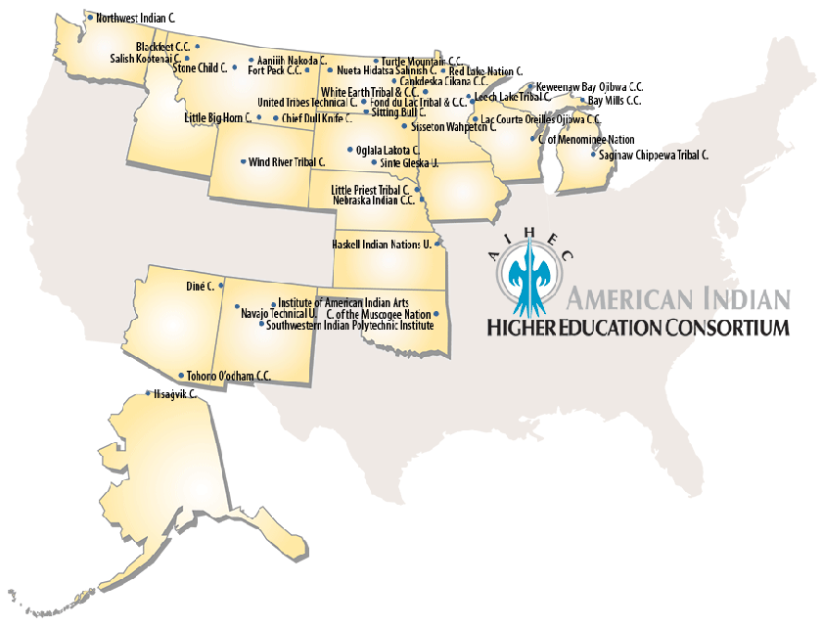

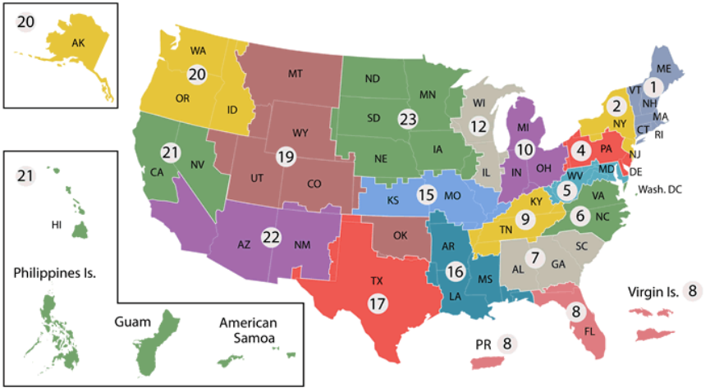

Appendix B: Additional Resources
- American Indian College Fund Homepage

- American Indian College Fund 2016-2017 Annual Report

- American Indian Higher Education Consortium Homepage

- American Indian Higher Education Consortium (2009). 2007 AIHEC AIMS Fact Book

- American Indian Higher Education Consortium (2012). 2009-2010 AIHEC AIMS Fact Book

- Podcast and transcript of American RadioWorks (2015). From Boots to Books.

- National Center for Veteran Analysis and Statistics (2015). Profile of Post-9/11 Veterans: 2012

- Relevant benefits and guidance from the U.S. Department of Veterans Affairs:
- Education and Training Opportunities
- Education Programs
- Applying for Benefits

- U.S. Department of Veteran Affairs 2015 Veteran Economic Opportunity Report

- VA Campus Toolkit: Additional Online Resources

