
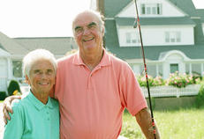

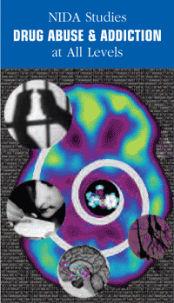

- Online screening for alcohol and drug problems and self-help information are available at My HealthE Vet:
- www.myhealth.va.gov
- If you are having any thoughts of harming or killing yourself, please let your provider know immediately or contact:
- Veterans Crisis Line
1-800-273-TALK (8255), Press 1
- suicidepreventionlifeline.org/
Veterans/
- National Call Center for Homeless Veterans
1-877-4AID VET (1-877-424-3838)
- If you experience any symptoms of withdrawal, please talk with a provider today or go to the emergency room for help.
- To schedule an appointment with the Substance Use Disorders Treatment Program, refer to contact information below:

T

VA Treatment Resources
Additional Resources
National Institute
on Drug Abuse
www.nida.nih.gov

Center for Substance Abuse Treatment/Substance Abuse & Mental Health Services Administration
www.csat.samhsa.gov
Drug Use:
Get the Whole Picture
Home Town VA
Medical Center
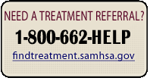
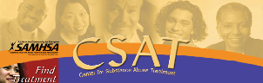
Substance Use Disorders Treatment Program
Home Town VA Medical Center
1111 Main Street
Anytown, US 12345
Phone: 123-456-7890
Toll-Free: 1-234-567-8910
Location: Floor A, Room #XYZ
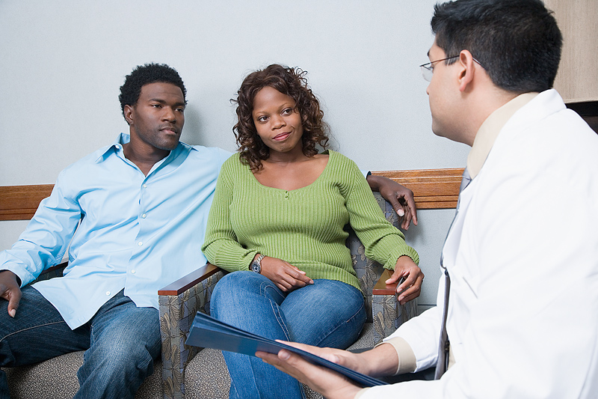
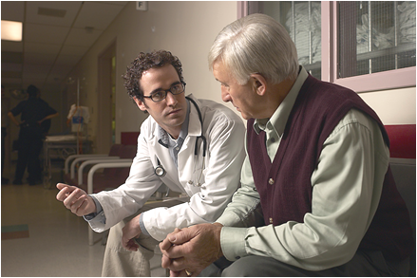

Tell Your Doctor about All the Drugs You Use
The VA is committed to helping Veterans. Problems with drugs or alcohol:
Are Common — 10 to 15 percent of all people experience them at some point in their lives.
Can harm you or those close to you in terms of health, happiness, or family relationships, among other things.
Can be successfully treated like treatments for heart disease, hypertension, diabetes, and asthma.

- Help for withdrawal.
- Choices in treatment.
- Outpatient or residential treatment based on your needs.
- Treatment shown by research to be effective.
- Access to FDA-approved medications for addictions.
- Care for other mental health concerns you may have, including PTSD and depression.
- Ongoing care based on your needs.
- Referrals for additional services.
Without the Whole Picture, You Might Not Get the Whole Treatment.
For the best care, your doctor needs to know the drugs you take, including tobacco, alcohol, illicit drugs, and over-the-counter medications.

“I found that being open about my drug usage has helped me tremendously. I can now face tomorrow.” -Clarence

“I was nervous about speaking up about my drug use, but I’m glad I did. I told my doctor about my prescription pill abuse and he helped me get into a detox program. Now I get the treatment I need and I have my life again.” -Brian

“Once a part of the substance abuse program you realize that you are not alone. The fellowship is great!” -Mike

What You Can Expect from the VA Substance Use Treatment Program:
Some Comments
From Veterans:

