Social Media Content

Topic: Clear The Air – What Matters to You
Facebook Copy | Instagram Copy |  | Twitter Copy
Smoking and the cravings that come with it can interfere with the moments you care about. When you’re ready to stop smoking, VA can help you #ClearTheAir. Talk with your provider today about tobacco use treatment options that can work for you. Learn more: mentalhealth.va.gov/quit-tobacco/how-to-quit.asp | Smoking and the cravings that come with it can interfere with the moments you care about. When you’re ready to stop smoking, VA can help you #ClearTheAir. Talk with your provider today about tobacco use treatment options that can work for you. Learn more: www.mentalhealth.va.gov |  | Smoking and the cravings that come with it can interfere with the moments you care about. When you’re ready to stop smoking, VA can help you #ClearTheAir. Talk with your provider today about tobacco use treatment options that can work for you. Learn more: mentalhealth.va.gov/quit-tobacco/how-to-quit.asp
Media Asset
Slideshow/Video
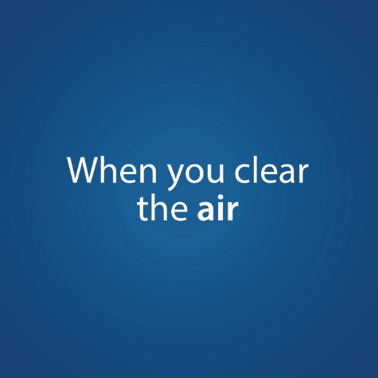
Topic: Clear The Air – Mental Health
Facebook Copy | Instagram Copy | Twitter Copy
It’s time to #ClearTheAir: Smoking not only harms your physical health but can affect your mental health too. People who smoke are more likely than nonsmokers to experience anxiety, stress and depression. Learn how quitting smoking with VA’s help can set you on a path toward better health: mentalhealth.va.gov/quit-tobacco/index.asp | It’s time to #ClearTheAir: Smoking not only harms your physical health but can affect your mental health too. People who smoke are more likely than nonsmokers to experience anxiety, stress and depression. Learn how quitting smoking with VA’s help can set you on a path toward better health: www.mentalhealth.va.gov | It’s time to #ClearTheAir: Smoking not only harms your physical health but can affect your mental health too. Learn how quitting smoking with VA’s help can set you on a path toward better health: mentalhealth.va.gov/quit-tobacco/index.asp
Media Asset
Slideshow/Video
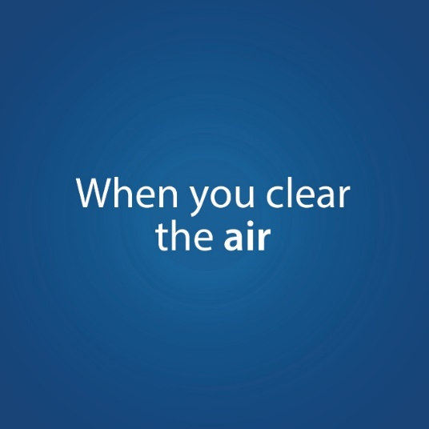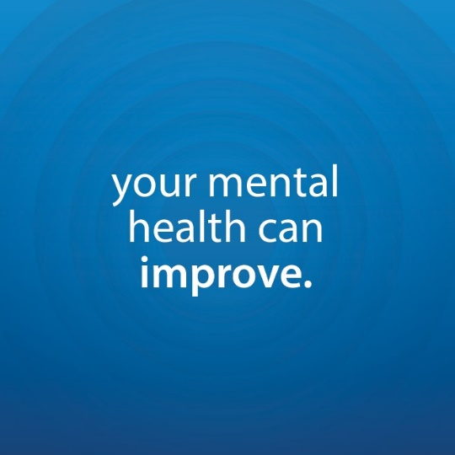
Topic: Clear The Air – Achieve Your Goals
Facebook Copy | Instagram Copy | Twitter Copy
How will your choice to quit smoking affect your everyday life? You may find you have more time, money and energy for pursuing your goals. Take the first step with VA toward a tobacco-free life and learn how you can #ClearTheAir for good: mentalhealth.va.gov/quit-tobacco/why-quit.asp | How will your choice to quit smoking affect your everyday life? You may find you have more time, money and energy for pursuing your goals. Take the first step with VA toward a tobacco-free life and learn how you can #ClearTheAir for good: www.mentalhealth.va.gov | How will your choice to quit smoking affect your everyday life? You may find you have more time, money and energy for pursuing your goals. Take the first step with VA toward a tobacco-free life and learn how you can #ClearTheAir for good: mentalhealth.va.gov/quit-tobacco/why-quit.asp
Media Asset
Slideshow/Video
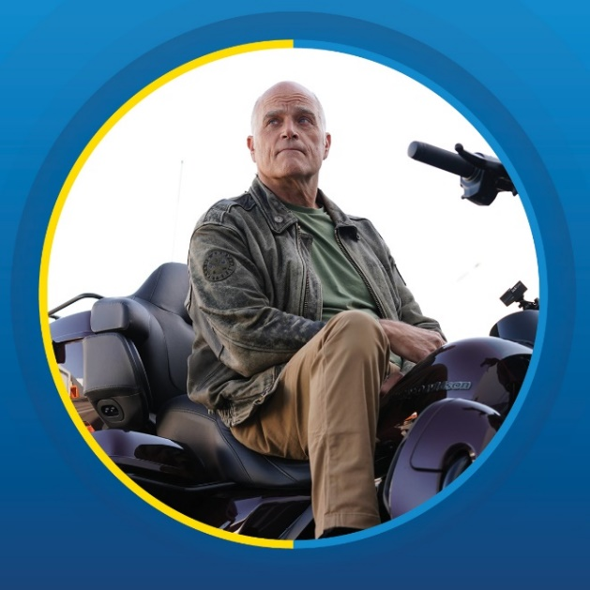

Topic: Clear The Air – Motivation for Quitting (My HealtheVet)
Facebook Copy | Instagram Copy | Twitter Copy
Whatever your motivation for quitting smoking — like saving money or better health for yourself and your loved ones — VA is here for you. Reach out to your VA provider through My HealtheVet’s Secure Messaging to learn more about how to achieve your tobacco-free goals: myhealth.va.gov  #ClearTheAir | Whatever your motivation for quitting smoking — like saving money or better health for yourself and your loved ones — VA is here for you. Reach out to your VA provider through My HealtheVet’s Secure Messaging to learn more about how to achieve your tobacco-free goals: myhealth.va.gov  #ClearTheAir | Whatever your motivation for quitting smoking — like saving money or better health for yourself and your loved ones — VA is here for you. Reach out to your VA provider through My HealtheVet to learn how they can help: myhealth.va.gov  #ClearTheAir
Media Asset
Graphic Photo

Topic: Clear The Air – SmokefreeVET
Facebook Copy | Instagram Copy | Twitter Copy
Let’s #ClearTheAir: Quitting smoking can be difficult, but you don’t have to do it alone. VA’s SmokefreeVET text messaging program provides on-the-go encouragement as you quit. To get started, text VET (o manda VETesp para apoyo en español) to 47848. Learn more: mentalhealth.va.gov/quit-tobacco/smokefreevet.asp | Let’s #ClearTheAir: Quitting smoking can be difficult, but you don’t have to do it alone. VA’s SmokefreeVET text messaging program provides on-the-go encouragement as you quit. To get started, text VET (o manda VETesp para apoyo en español) to 47848. Learn more: www.mentalhealth.va.gov | Let’s #ClearTheAir: Quitting smoking can be difficult, but you don’t have to do it alone. VA’s SmokefreeVET text messaging program provides encouragement as you quit. To get started, text VET (o manda VETesp para apoyo en español) to 47848: mentalhealth.va.gov/quit-tobacco/smokefreevet.asp
Media Asset
Graphic Photo

